Assignment 13
Problem Statemet :
Implement bubble/quick sort Algorithm using scala programming
Code :
import org.apache.spark.sql.SparkSession

object SparkSort {

def quickSort(arr: Array[Int]): Array[Int] = {
if (arr.length <= 1) arr
else {
val pivot = arr(arr.length / 2)
Array.concat(
quickSort(arr.filter(_ < pivot)),
arr.filter(_ == pivot),
quickSort(arr.filter(_ > pivot))
)
}
}

def main(args: Array[String]): Unit = {

val spark = SparkSession.builder()
.appName("Sort Example")
.master("local[*]")
.getOrCreate()

val data = Array(5, 3, 8, 1, 2)

val sorted = quickSort(data)

println("Sorted Data (Quick Sort):")
sorted.foreach(println)

spark.stop()
}
}

Output :
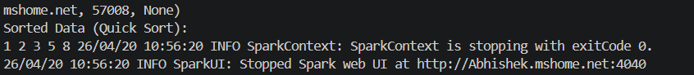

Analysis :
In this assignment, Quick Sort algorithm is implemented using Scala programming. The dataset is sorted using divide and conquer approach where a pivot element is selected and the array is recursively divided into subarrays. Apache Spark framework is used to initialize the environment, although sorting logic is implemented manually using Quick Sort.

